React.js and Node.js

Pre-requisites:

HTML

CSS

JavaScript

Software’s Required

1. Editor - Visual Studio Code : <https://code.visualstudio.com/download>
2. Node.js - Runtime environment for Javascript to run at the backend: <https://nodejs.org/en/>
3. Browser - Runtime environment for Javascript to run at the frontend
4. Internet - Open internet to download node-modules

Things to know before going to React.js & Node.js

* HTML
  + div, p, h1,..h6, table, form, img and so on.
* CSS
  + id, class, properties & values
* Javascript
  + Fundamentals
  + Functions & Variables
  + New Features of Javascript (EcmaScript latest features)
    - classes, let, const, super, extends
    - Arrow functions, template string literals
    - Rest & Spread operators
    - Default arguments
    - PadStart & PadEnd
    - Exponential operators
    - Generators

Refresher on JavaScript

There are mainly 3 ways you can print the output in the Javascript

* document
* alert
* console

document: It is an inbuilt Javascript object that helps you to access the browser DOM (Document Object Model), it helps to access various functions like write(), getElementById(), getElementsByTagName() and so on.

alert: It is mainly to show the pop-up box, for any kind of warning or some messages

console: It is mainly to debug the javascript if you want to see any output you use log(), or if Javascript has any errors those are logged in the console.

first.html

You can use html in the beginning to see the html default template in the VScode which is auto-created

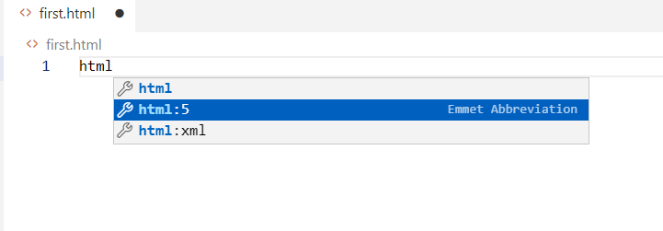

Then you see as

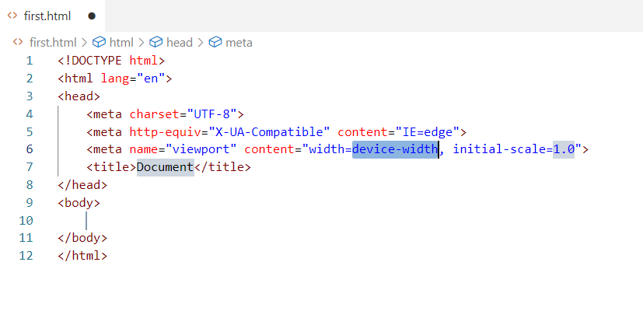

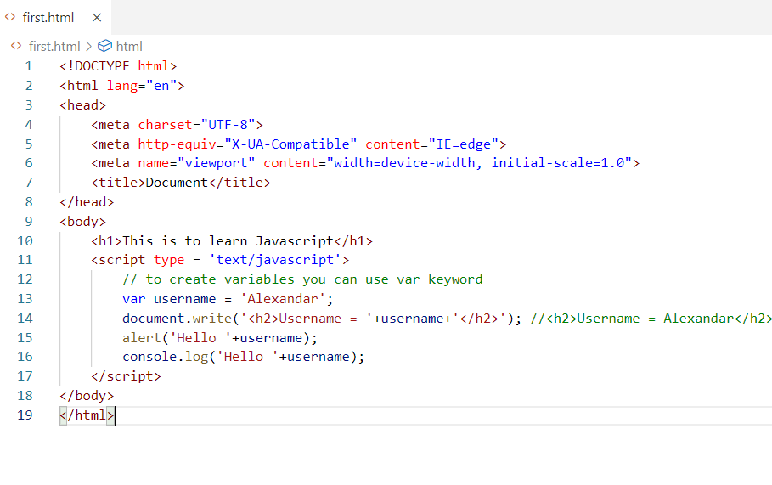

Output:

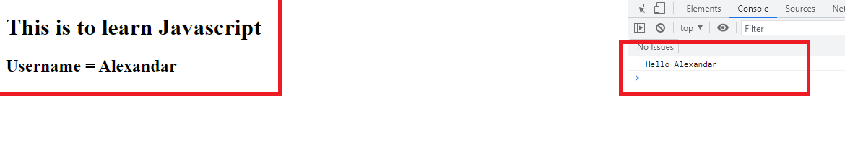

Fundamentals of JavaScript

* operators: ++, --, *, /, +, -, =, <, >, <=, >=, ==, ===, !=
* arrays
* loops: for, while, do-while
* conditions: if, if - else, if else if, else, swtich
* functions
* objects
* events

operators.html

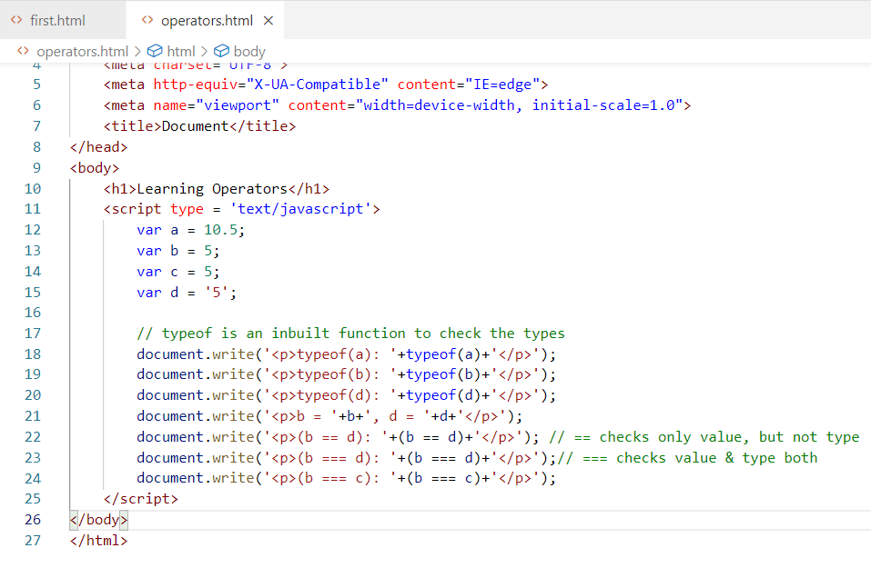

Here typeof checks the data type, in Javascript we have datatypes like number, string, boolean, object, Date,

Output:

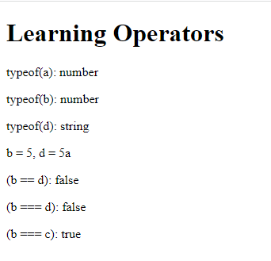

Activity:

1. Try out other operators like <=, >=, !=, ++, -- to understand how they work

Arrays: It is a collection of data, in Javascript you can have arrays with various types in a single collection, it used by []

items = [2, 1, 6, 7]; // valid

items = [“hello”, “test”, “demo”]; // valid

items = [2, “test”, “demo”, true, 5.15]; // valid

You can always use loops to iterate the array

arrays.html

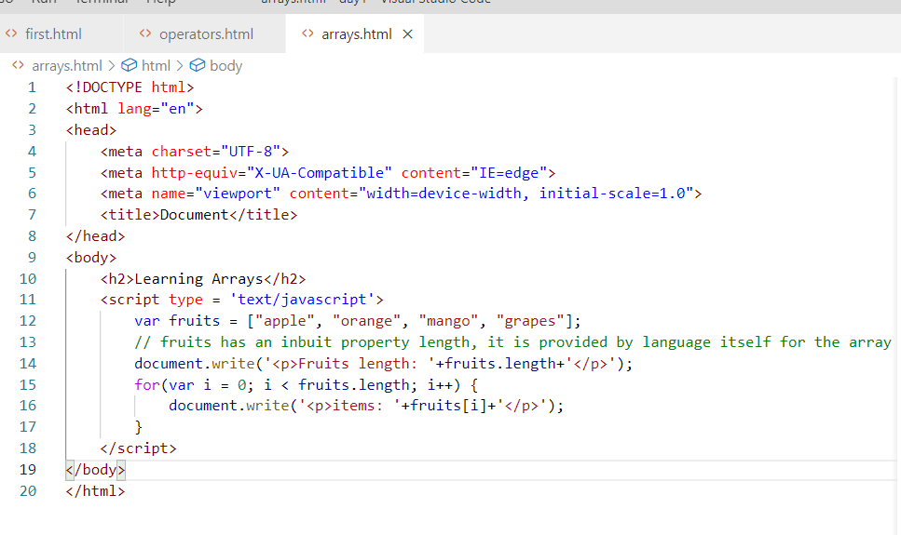

Output:

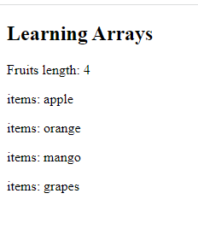

Creating Objects in Javascript

There are two ways you can create object in Javascript

1. Creating an object with {} having properties & values
2. Creating a constructor function that initializes the object

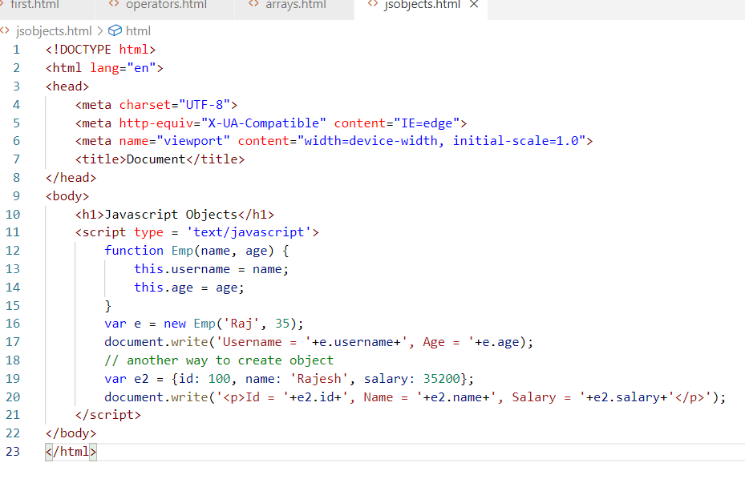

Output:

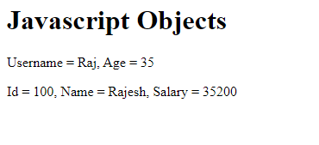

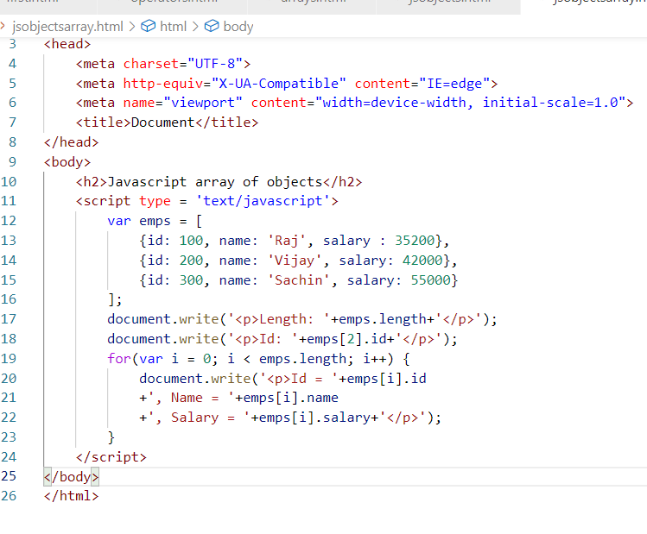

Output:

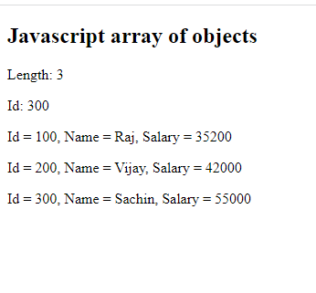

How to handle events:

Events are the things which are generated when user does some action on the HTML elements like click, mouseover, submit, change and so on.

In Javascript we can handle this event using the event attributes and their corresponding handler called function to handle.

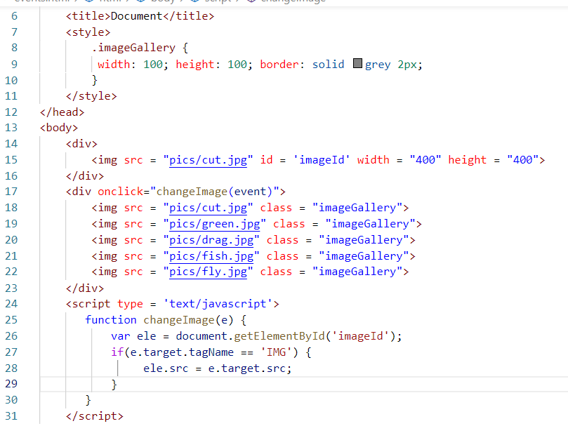

Output:



There are many ways to get the element

1. event.target
2. document.getElementById()

Activities:

1. Try out all the above examples
2. With your own examples try different operators like <, >, <=, >=, !=
3. Try while & do while loops in Javascript and check out how it works
4. Display the array of employees in a table having rows & columns, use <table> tag to create tables and use the array having employee objects as below

 var emps = [

            {id: 100, name: 'Raj', salary : 35200},

            {id: 200, name: 'Vijay', salary: 42000},

            {id: 300, name: 'Sachin', salary: 55000}

        ];

Solution:

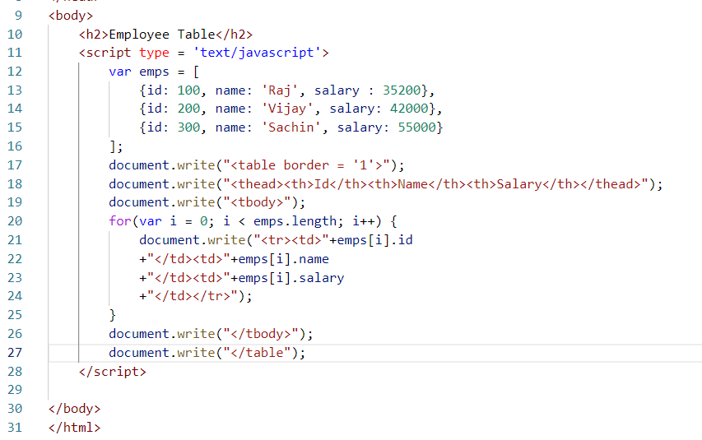

Output:

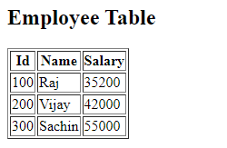

ECMAScript (European Computer Manufacturing Association):

It is a standard that specifies set of features so that their specifications can implement, ECMAScript specifications are

* Javascript
* Typescript
* JQuery
* Node.js
* Browser
* JSX

ECMA Script is also called as ES it has released lot of new features from V6 onwards till now, V6 was released in 2015, all these new features are understood by browser, node.js and even Javascript.

New Features of ECMAScript

These simplifies writing Javascript code

1. let, const, class, extends, super, constructor
2. Template Strings
3. Rest, Spread & Default Parameters
4. Arrow Functions
5. Destructuring
6. padStart & padEnd
7. Exponential Operator
8. Optional Chain
9. Object entries & values
10. static keyword

let & const

These are the two keywords you can use to declare variables in Javascript apart from var, let & const creates scopes for the variables.

var is always global, means you create variables with var it will be considered as global variable it is not part of any block of code, sometime you want to protect your variables within a block of code then through var its not possible, but possible through let & const

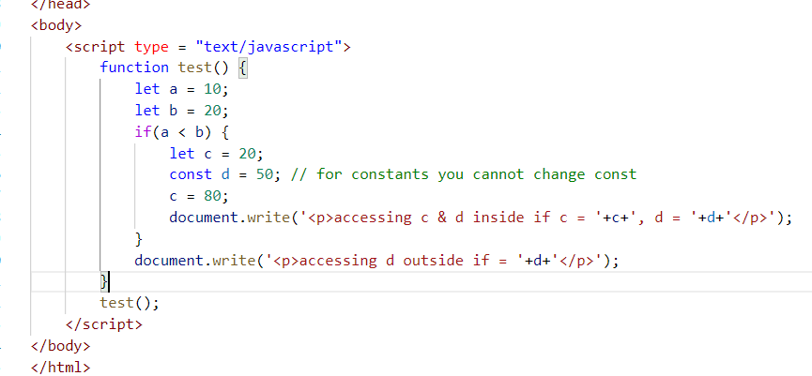

const variables can’t be modified

Output:

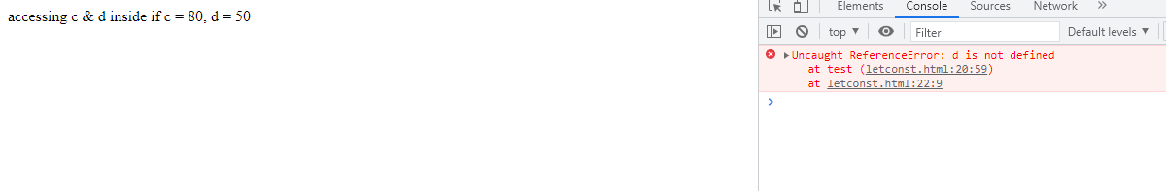

Callbacks: These are functions that are called after some time but not immediately, this is mainly used to perform asynchronous operation

function abc() {   
  
}

abc();

x = 10;

y = 20;

abc();

z = 30;

The above statements are synchronous, every statement waits for their previous statements to complete first

Asynchronous calls are the calls that doesn’t block the next statement to execute, the asynchronous calls may happen at any time but other statements doesn’t wait for asynchronous call to complete, it can be achieved only by callbacks

x = 10;

asynch call

y = 20;

z = 30;

asynch call

a = 50;

Asynchronous calls don’t block you to do the next operation, these calls may give response late but user doesn’t need to wait for the response to perform the next operations.

ex: Google search let user enter input and it sends each input to the server to fetch the response, but user can continuously enter the input without waiting for the response their previous request

Callbacks are the special kind of functions they are called separately to make operations asynchronous & we wouldn’t be having idea when they are going to complete.

Best example is we can use setTimeout(callback, time);

setTimeout: It is a function that takes callback as an argument, i.e., function as an argument which is called after a specific duration mentioned, but the other statements after setTimeout() is not blocked for callbacks to complete.

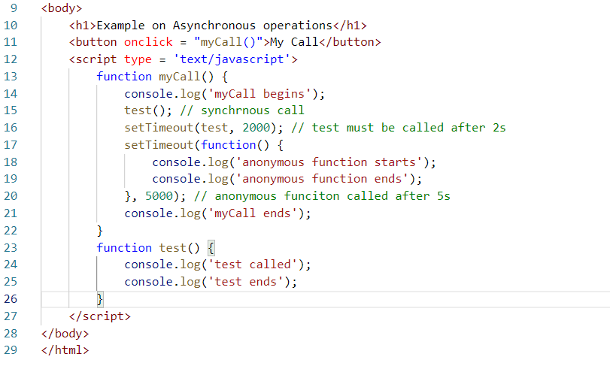

Here the 15th line is executed and after it completes then the 16th line is executed once it completes then 17th line is executed, but the callback passed as an argument at 16th is not going to block 17th line to begin the execution, they are callbacks which are executed once the specific duration mentioned is completed, here the callbacks passed to setTimeout at 16th line & 17th line doesn’t block 21st line at all, because these callbacks are executed later without blocking 21st line.

Note: setTimeout is not an asynchronous function, it takes the callback to execute after some time, that callback is an asynchronous.

Note: Not all callbacks are asynchronous

When to use asynchronous functions or callbacks

Suppose you have a script that has statements which needs to fetch the data from the server then the script doesn’t need to wait for the data to be available, because we don’t know when the data will be available, till that time you can’t block the script from execution, hence the fetching data must be Asynchronous, similarly lot of File IO operations can be asynchronous.

There are some callbacks which are not asynchronous, we can still write them without naming the function i.e., anonymous functions.

ex: forEach(), map() and so on.

Two ways of iterating the arrays using callbacks

1. forEach(): it iterates the array & invokes the callback for each iteration and callback will have 2 arguments 1st one is item that is iterated & 2nd one is the index of the item.

Note: callback argument names can be anything, but we can use item, index to understand

1. map(): it iterates the arrays & invokes the callback for each iteration but returns the new array, it is used to iterate and perform some operations on the iterated item, it is used when you want to convert data to another data

Note: the callback of map also takes 2 arguments similar to forEach

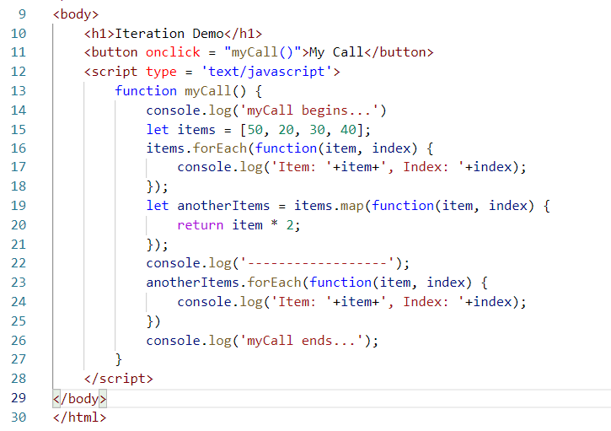

Output:

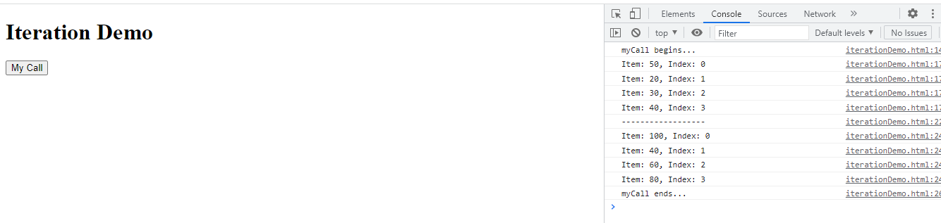

Arrow function:

It is a new feature of ECMAScript that simplifies writing anonymous functions or callbacks, it doesn’t need any function keyword and doesn’t need body of the function to have {} if its one line statement, doesn’t need return if its one line statement

They are written with () => statement

Some of the way of writing arrow functions

() => 20; similar to function() { return 20; }

(x, y) => x + y; similar to function(x, y) { return (x + y) }

() => console.log(‘hi’); similar to function() { console.log(‘hi’) }

If arrow functions need to be written with morethan one line they you need { }

() => { console.log(‘hi’); return 20; }

The above code is similar to

function() {  
 console.log(‘hi’);

return 20;  
}

The arrow function needs to use return statement mandatorily once {} are used

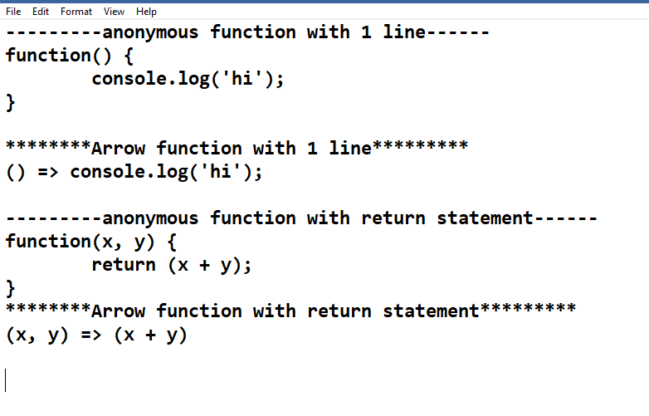

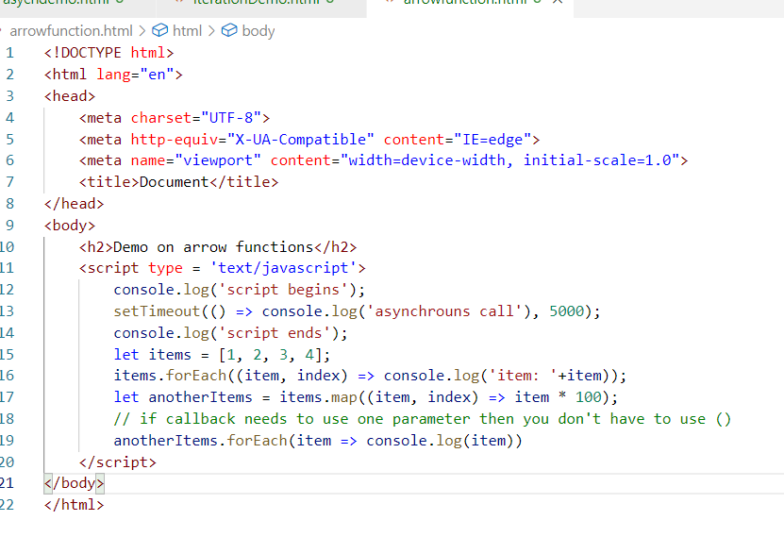

Output:

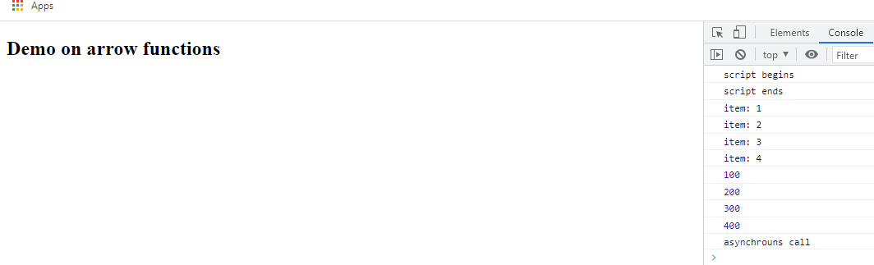

ECMAScript new features like Rest, Spread operators

These two solves certain problems while passing arguments to the functions while calling.

Rest: It is a parameter that can accept 0 or more number of arguments, it is going to take rest of the data while accepting the data

Spread: It is to share the data to multiple parameters of a function, it is going to spread data to multiple parameter of a function

Rest operator:

It is a parameter that accepts 0 or more values and it needs to be at the end of the function parameter, if in case a function has more than one parameter

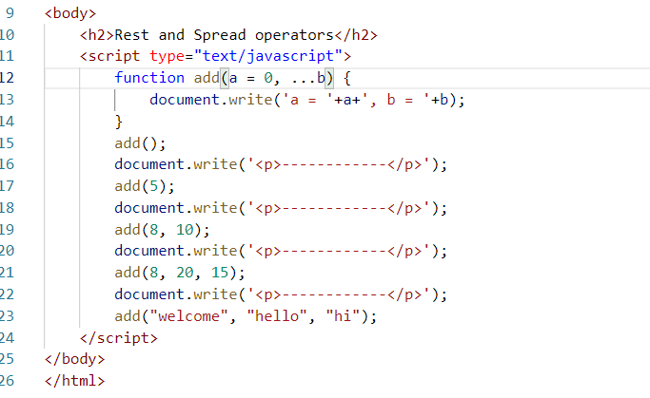

add(a = 0, …b) means a accepts 0 if in case add() is called without any value to a, b anyways by default will be an empty array, you can always iterate rest parameter variable using for loop.

Output:

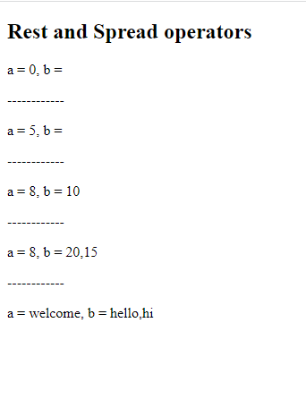

Note: In Javascript a variable can take any kind of value, there’s no specific that it accepts only a specific type of value

Spread operator

When you have multiple values in an array you can spread them to a function matching to multiple parameters

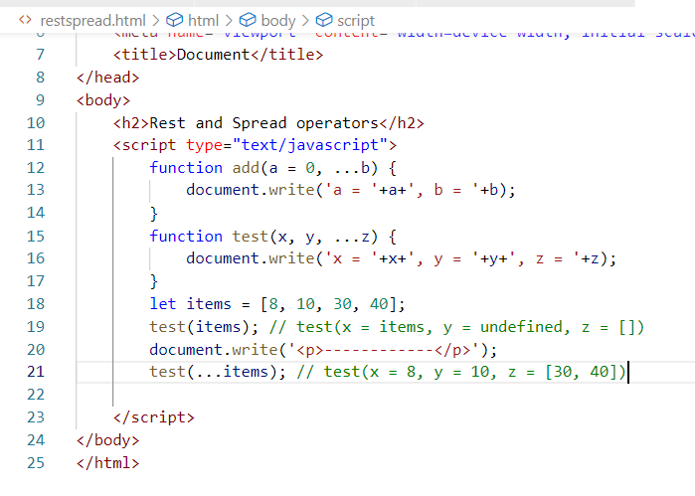

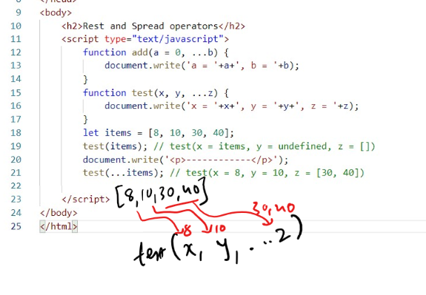

Here the 19th line is accepting the array hence the test(x, y, …z) will accept the array for x variable, but y & z doesn’t get any value

But 21st line is using spread(…), hence the values of array is spread to the parameters of the function that matches to the number of elements in the array, since items has 4 elements & test() accepts 3 arguments and the last one is rest operator, then the 1st two elements are assigned to 1st two parameters i.e., x = 8, y = 10, z = [30, 40], whereas z is rest operator hence it accepts rest of the elements.

Output:

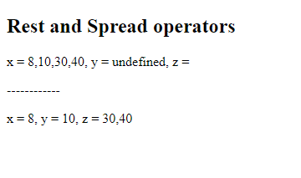

The above code uses 3 new features of Javascript

1. Rest Operator
2. Spread Operator
3. Default argument

Default arguments: It is an argument to a function if the value is not supplied then the default is taken

function test(a = 0, y = 0){ } if test is called without values then a & y will be 0, if test is called by passing values like test(20), then a will be 20, y will be 0, if its called test(20, 30) then a = 20, y = 30.

Template String literals

It is used to create strings with dynamic value without breaking the strings with + operator, because when you concatenate the strings with dynamic value you need to break the string with + operator and concatenate the dynamic value, to avoid that we have a template string literals.

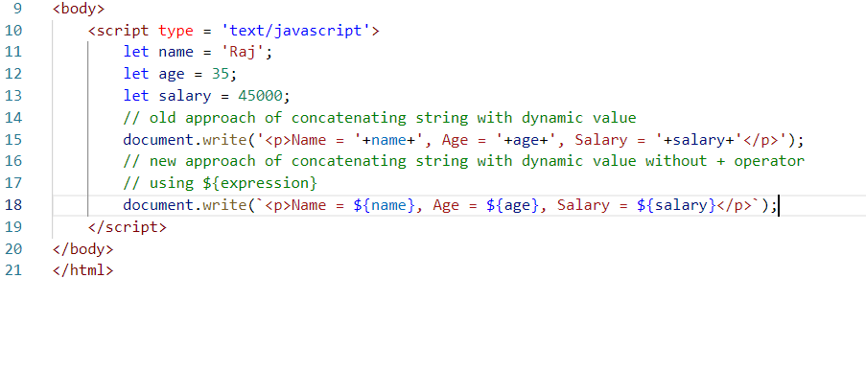

Output:

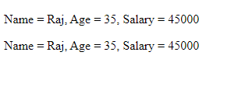

class, constructor, extends, super keyword

These are the new keywords added in Javascript to easily create the functions part of the object & also inherit the object from another object

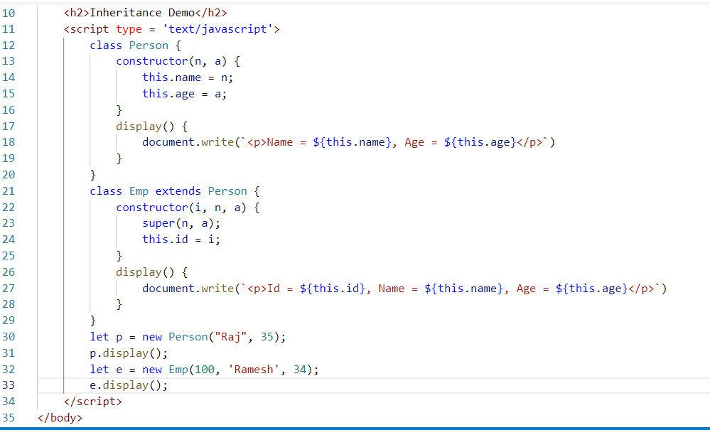

Output:

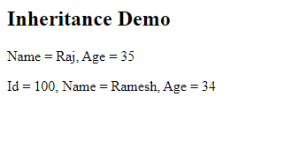

ECMAScript new features like exponential operator, trailing commas, optional chain

Exponential Operator: You can easily find the power of 2 numbers using ** now, suppose you write 2 ** 3 then it returns 2 power 3 i.e., 8, if you use 3 ** 3 then it returns 3 power 3, i.e., 27

Trailing commas: Javascript ignores the extra commas if in case you did a mistake while creating arrays, earlier it was an error, but now Javascript ignores it as extra commas are trailed ie., removed

Suppose you write [10, 20, 30, ] here after 30 an extra comma is automatically removed.

Optional Chain: It allows you to access a nested property with a condition like if exists access else don’t access, earlier developers need to write many conditional statements to check the existence of nested properties

i.e., users = [{id: 100, name: ‘Raj’, address: {state: ‘ka’, city: ‘blr’}, {id: 122, name: ‘Ajay’}]

Here users is an array, where first user object has address.state & address.city, however the second user object doesn’t have address property so we can use optional chain

Here when you iterate you usually iterate the item by accessing each property & their property, but chances are there you could get error, as address is not there in the 2nd object.

you can use optional chain in each iteration so that it access address if exists else doesn’t access.

item.address.state : chance of error, if address is undefined

item?.address?.state: will access address if exists else not

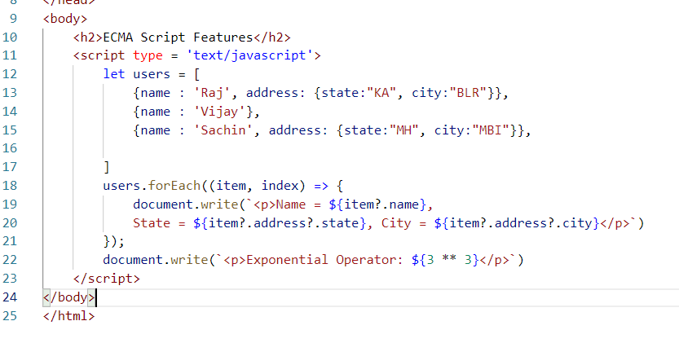

The 15th line has extra comma, which is ignored, the 19th & 20th line will access name and address only if they exists, so that you get no errors, 22nd line is using exponential operator.

Output:

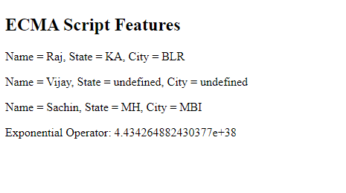

Activity:

1. Using template string literal create table rows dynamically to show user information’s, use the below array as it and show the data in the table with border

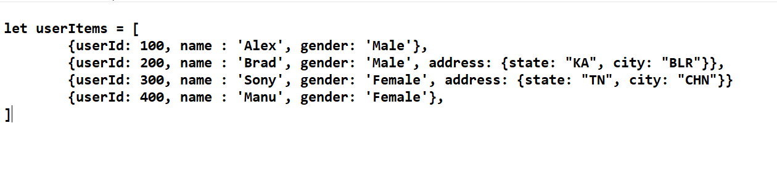

Display the above user details in the table, the table must have headings and the data must be printed through Javascript not by hardcoding

Note: Use <div id = “root”></div> and below that create a button once you click on the button the table must be added inside the div#root

Hint: use map() function.

Expected Output

|  |  |  |  |  |
| --- | --- | --- | --- | --- |
| **ID** | **NAME** | **GENDER** | **STATE** | **CITY** |
| 100 | Alex | Male |  |  |
| 200 | Brad | Male | KA | BLR |
| 300 | Sony | Female | TN | CHN |
| 400 | Manu | Female |  |  |

Summary:

* Javascript fundamentals
* Event Handling
* Object
* ECMAScript features
* let, const, class, constructor, extends, super
* Default, Rest & Spread parameters
* Template String literals
* Arrow functions
* Optional Chain
* Exponential operator

Node.js

It is a runtime environment to execute Javascript code without browser, you can write backend programs that can perform various backend operations like IO operations, DB operations, Request Handling and so on.

Node.js provides lot of Javascript libraries which are called as node_modules using which you can perform any kind of operations.

Now you can use Javascript for both UI development as well as Backend Services i.e., Full Stack Development can be done with a single language

Node.js can directly run Javascript files and since it doesn’t use browser you can’t use some of the inbuilt objects & functions that are used for the Frontend UI’s like document, window, alert(), however Node.js can solve a different requirement like interacting with DB, File systems, OS resources and so on.

Benefits of Node.js

* Developers don’t need to switch to different language to write backend programs
* Enable developers to write entire application in one language i.e., Javascript
* JSON is the common format used to exchange the data between front end & backend applications & JSON is the native language to Javascript
* Many of the NoSQL database(MongoDB, CouchDB) store their data in JSON format, if node.js interacts with it then it will be easier for Node.js to understand their data
* Node.js gives you an environment which allows you to run the scripts without Javascript file i.e., node terminal

To open node terminal

* In CMD prompt enter node
* To exit use Control + C

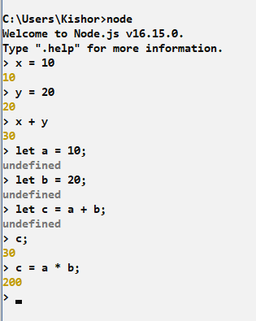

But these programs are not saved in any file, once you come out of the terminal these codes are gone, hence you need to create a JS file and run that using node command

You can create one file named app.js or index.js or main.js or anyname.js and you can write Javascript code & run using node filename.js

day3/main.js

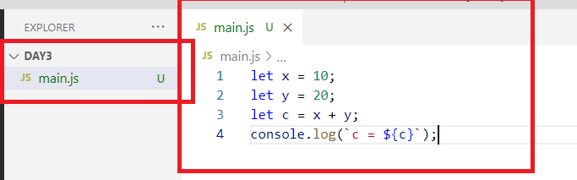

Output:

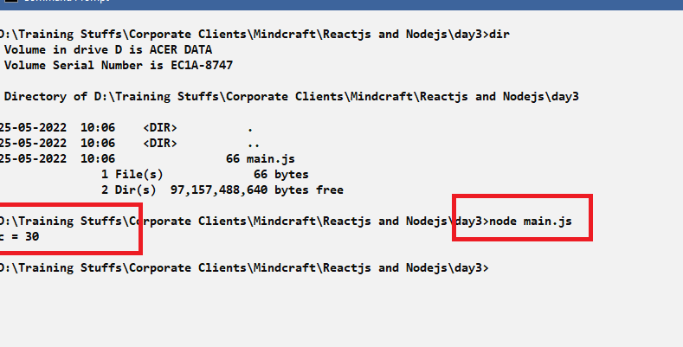

Note: While practicing create different filenames for each program like ex1.js, ex2.js, ex3.js and so on.

You can use asynchronous functionalities also in node.js programs that is callbacks that can be supplied to the setTimeout, setInterval kind of functions.

day3/main.js

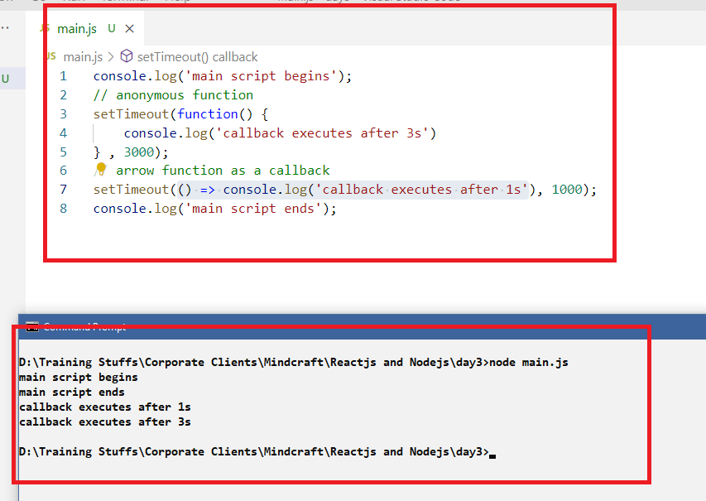

Node.js also doesn’t block other scripts when an asynchronous call is made, it uses a mechanism called Event Looping behind the scene

Event Loop in Node.js

Node.js uses a single thread to run the script, it is not multi-threaded, with single thread & event looping mechanism it can perform all the IO operations without blocking other scripts.

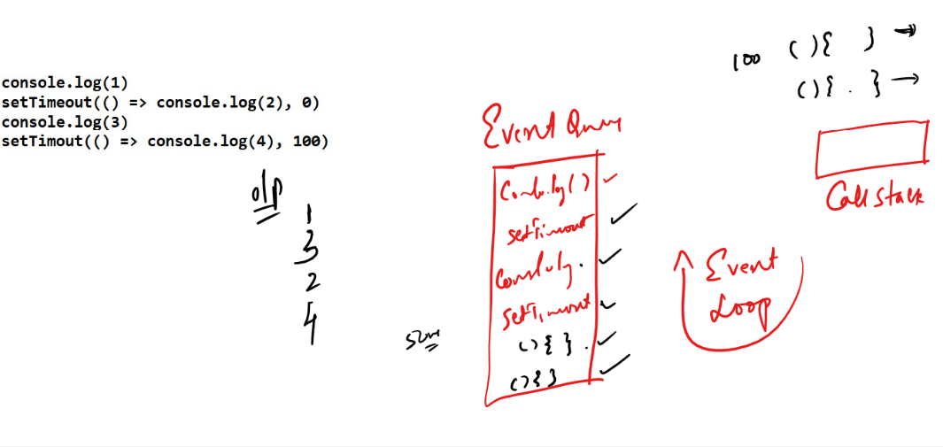

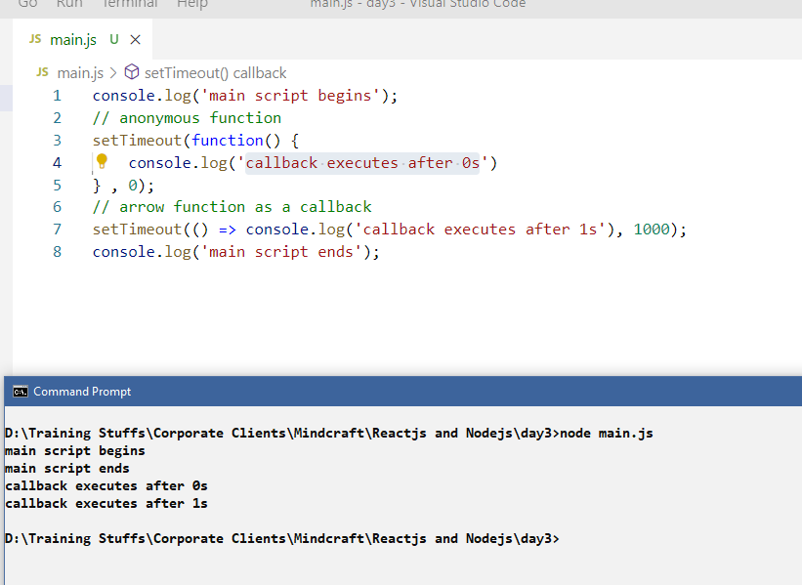

Modules: These are reusable code that can be used in any Javascript files to access their functionalities

There are mainly 3 types of modules

1. Core Modules: These are functionalities available in node.js itself
2. Local Modules: These are functionalities which you can create and use it in any Javascript
3. Third party Modules; These are functionalities which are available from the internet which you can download and use in your script.

Local Modules

These are the modules we can create in our local machine and use them in any scripts

mymodules.js

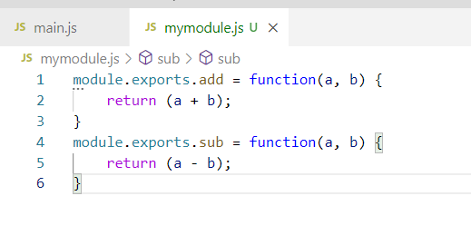

Here module.exports helps your script to import these functions like add and sub

We need to use require(“”) to import these modules

main.js

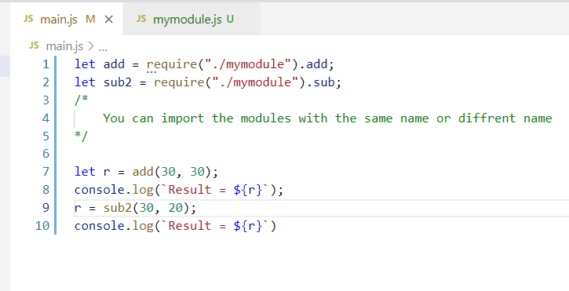

Here require(“path”) need to mention only the path & the filename and file must not have any extension like .js, we can import the module with any names, but its better to keep same names to easily understand which function we are calling

Output:

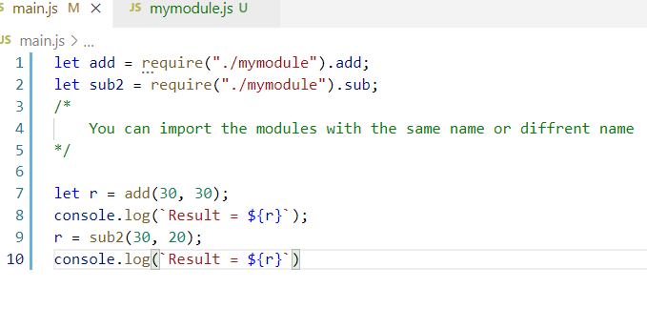

You can also import multiple functions from an object

You can use this to avoid multiple exports statement for each function name, this is good when you have all the functions in an object and directly export all the functions using the object name, you need to write the exports at the end of the file

mymodule.js

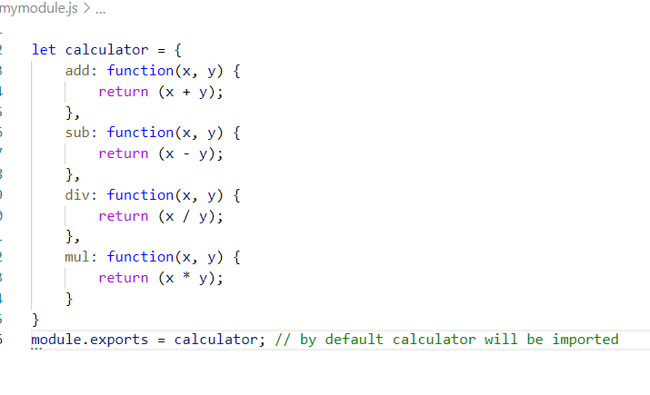

main.js

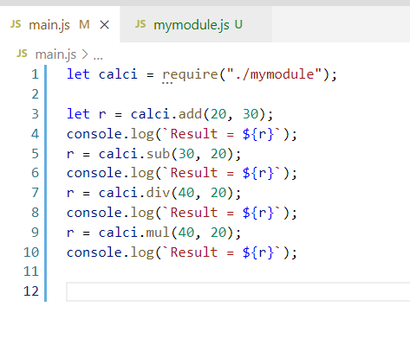

Note: the let calci = require(‘./mymodule’); imports the default module, hence you need to have only one default exports in a module, but you can have any number of named exports

Some functions can be made private to the module so that they can’t be exported

mymodule.js

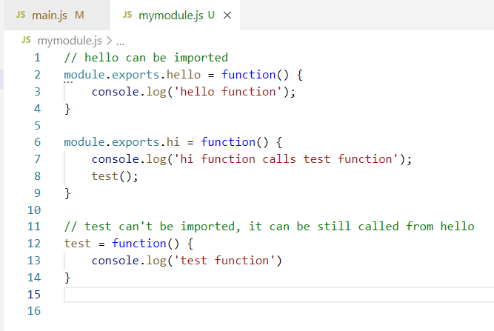

Here you can import hello() & hi() but not test

main.js

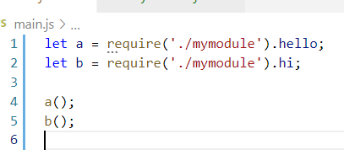

Basically you have two types of exports

1. Named exports which will have export for each modules
2. Default exports which is used when there is only one module to export

Named Exports

module.exports.add = function() { }

module.exports.sub = function() { }

Default Exports

let obj = {…..}

module.exports = obj;

Note: You can have only one default exports in single Javascript file

Use of default exports is you can together import all the features of the module

Named Exports vs Default Exports

|  |  |
| --- | --- |
| Named Exports | Default Exports |
| You can have any number of named exports in a module | You can have maximum one default exports in a module |
| You need to use the name and import the named modules  i.e., let a = require(“mymodule”).add  Here a is having add module | You don’t need to use the name at all while importing default module, it automatically imports default module only  i.e., let a = require(“mymodule”)  here a is having the default module |

You can also export other modules like functions, objects, classes, variables

mymodule.js

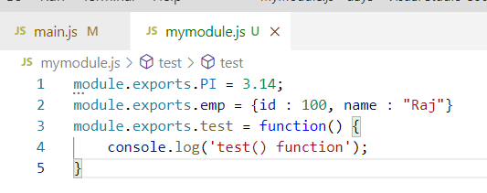

Here there are 3 modules which needs to be imported using the names PI, emp, test

main.js

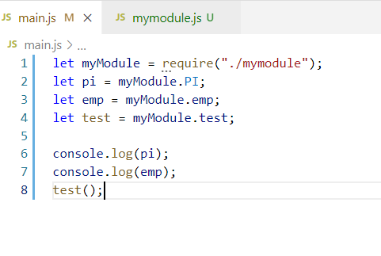

Output:

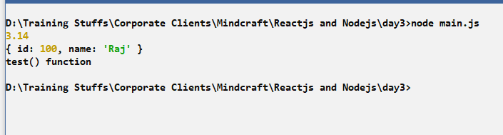

Core Modules

These are by default available from the node.js which you can import and use them in the script

Some of the core modules are:

1. os
2. fs
3. http
4. readline
5. util

OS Module

You can use this to extract the details of your os like arch(), platform(), release(), type(), freemem()

main.js

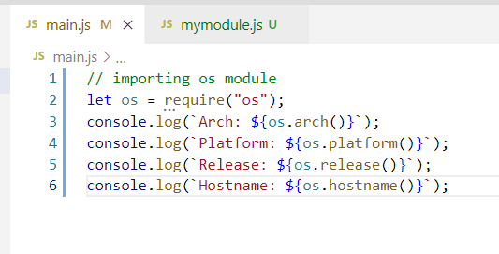

Output:

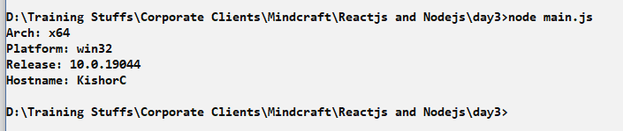

We could see x64 for arch() as it’s the 64-bit architecture, we see platform win32 as it is Windows platform, and release number is 10, since its Windows10, Hostname prints the username.

fs: (File System) File Handling

Node.js can perform read/write operations on files using a module called fs

This module provides functions like readFileSync(filename) to read the data and writeFileSync() to write the data to the file.

demo.txt

Write some content in demo.txt file

main.js

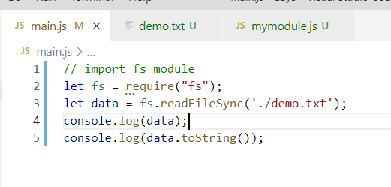

Here the readFileSync reads the file content and returns the data in Buffer format which needs to be converted to string format to understand what is the data.

Output:

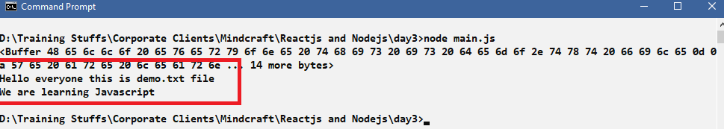

You can also read the data having some details separated by some delimiter

demo.txt

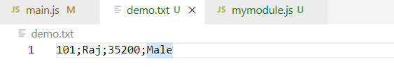

Now you want node.js to read the content as separate data like id, name, salary, gender

Since when you read the content it reads as a string, we can make use of one built function of string called split(delimiter), this splits the string into multiple strings based on delimiter

Suppose the data is Raj;Male;3000, then you can use data.split(“;”) then you get an array of string which will have [Raj, Male, 3000] which you can assign to variables either by using destructure or index based assignment

main.js

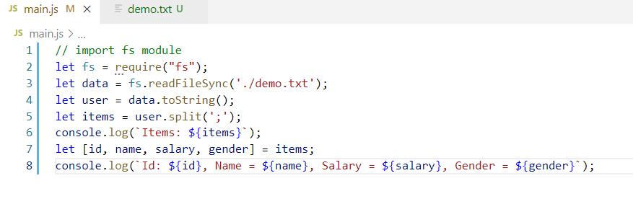

Here user will have the entire content of the txt file & split(‘;’) splits the content to multiple strings and stores in the array, since ; is delimiter we get 4 items in the array as we have 100;Raj;3000;Male it will be stored in an array as [100, Raj, 3000, Male], we have used array destructuring to assign each items into the variables

Output:

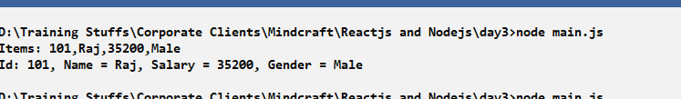

Writing data to the file

Using writeFileSync() we can write the data to the file

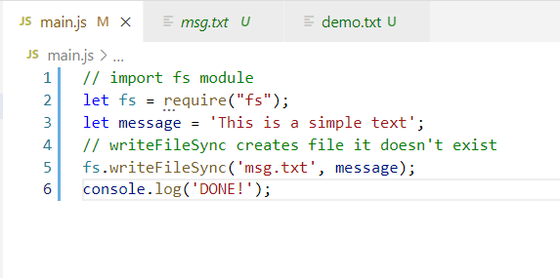

Output:

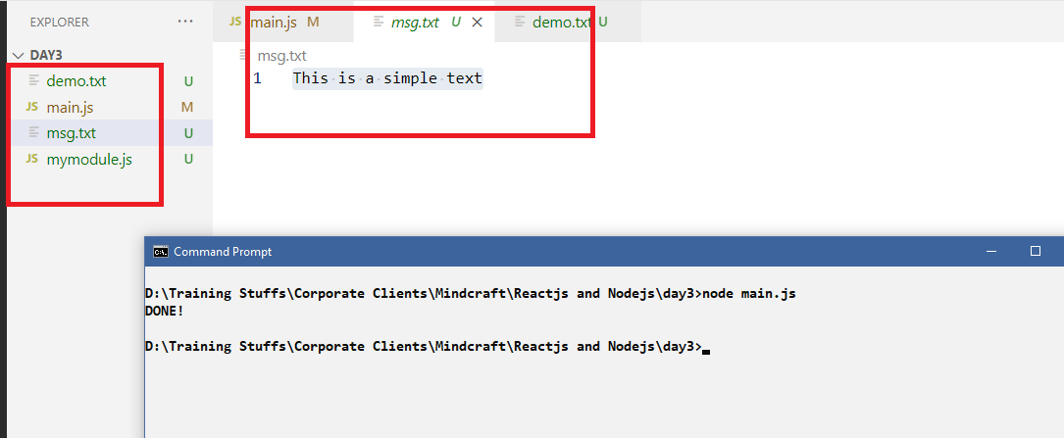

writeFileSync doesn’t automatically append the new content with the previous content, hence you must use a flag : ‘a+’} in the third argument of writeFileSync.

Whats the problem if we don’t use {flag:’a+’}

It erases older data and keeps only the current data you write, to avoid that we need to use {flag: ‘a+’} in the 3rd argument of writeFileSync.

main.js

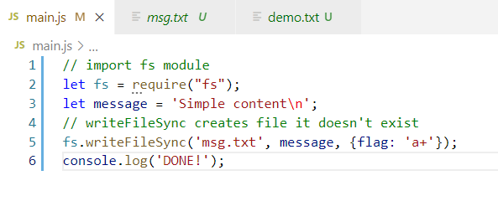

Output:

You will see the msg.txt retaining old content because {flag:’a+’} makes writing appendable.

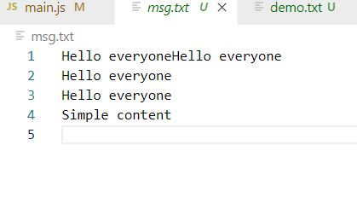

JSON:

Javascript Object Notation, it is a datastructure used to share the data between client & the server when they are completely written in different language.

You can store the JSON data in a JSON file

If you want to store single JSON data then you can use   
{“key”:value, “key”:value}

If you want to store multiple JSON data then you must store in an array format

[  
 {“key”:value, “key”:value, “key”:value}  
]

JSON is the native language for Javascript because it almost looks like Javascript object, but Javascript objects will have properties without double quotes.

Javascript Object:

{id: 100, name : “Raj”}

Then the corresponding JSON format will be

{“id”:100, “name”:”Raj”}

Javascript provides some inbuilt functions to convert Javascript to JSON and Vice Versa

Converting Javascript objects to JSON

JSON.stringfy(javascriptObject);

Converting JSON to Javascript objects

JSON.parse(jsonData);

main.js

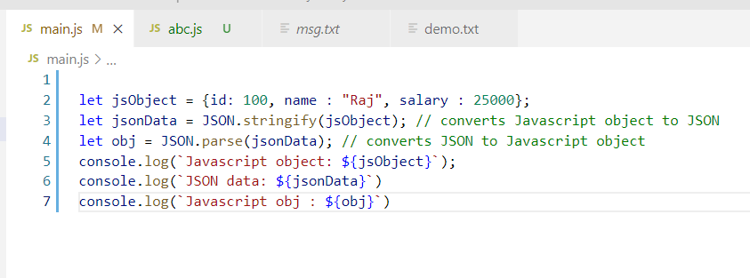

Output:

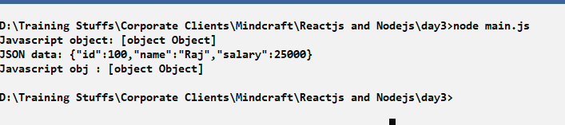

Here single program has a code to know how JSON is converted to Javascript & Javascript is converted to JSON, but in realtime there will separate programs who will have Javascript and converts to JSON and another program will have JSON and converts to Javascript.

Activity:

1. Store the javascript object in a JSON file by converting javascript to JSON, the JSON file extension will be ‘.json’

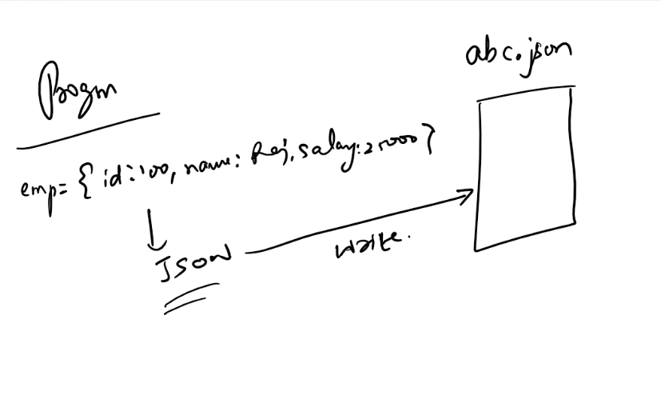

1. Read the above JSON file and convert the JSON data to a Javascript object and access their properties & print in the console.

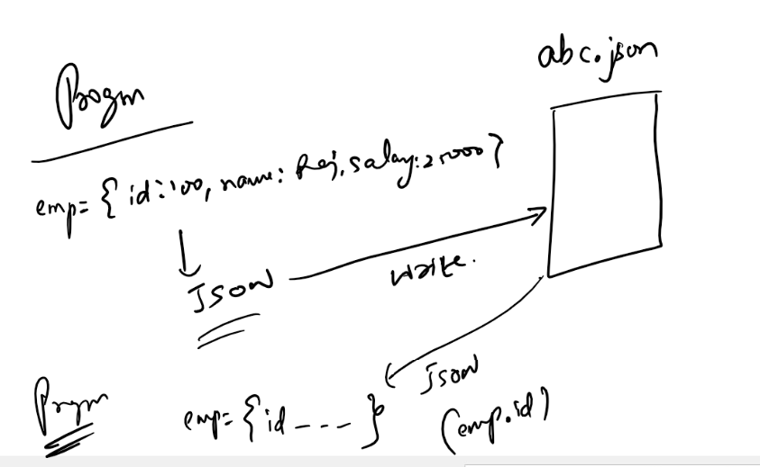

Solution:

Writing JSON to JSON file by converting Javascript object to JSON

writeJSON.js

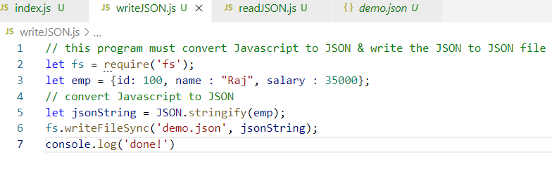

Here the 3rd line is a Javascript object which can’t be written to the File, it needs to converted to JSON, but we need to assume that this program is sharing its data to another application, hence we need to convert Javascript object to JSON, but for understanding purpose we have JSON file as an intermediate data for different applications.

Run the writeJSON.js using node writeJSON.js

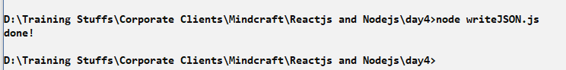

You will see a json file in the directory

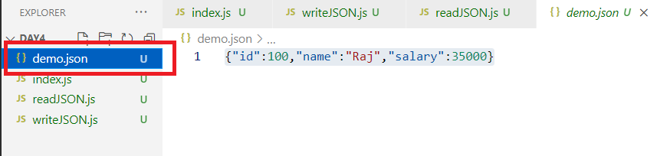

Now if this JSON data is shared by other applications and if Javascript needs to understand then it must convert the JSON string to Javascript object, but as JSON is in json file we need to read the JSON file, here also we need to make an assumption that some application wants to share data to the Javascript application

readJSON.js

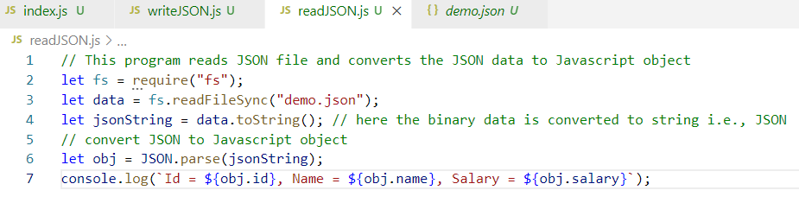

Run the readJSON.js

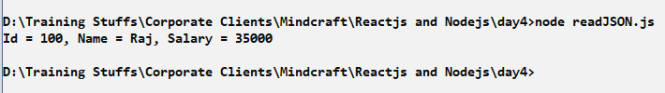

Activity:

Keep a JSON array in the json file and show each data in the console by converting the JSON array to Javascript array.

demo.json

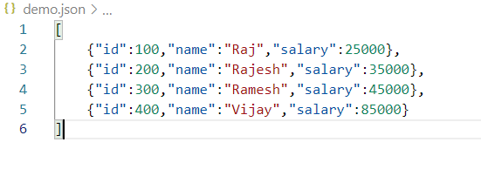

Show each object id, name & salary in the console.

HTTP module:

It is a core module used to handle request from the user and provide response in HTML format, it is used to develop web application

This module as a function called createServer() which takes a callback which is executed when request is sent to the server.

http.createServer(callback): the callback is a function with 2 arguments 1st is request & 2nd is response, once the createServer() is called you need to call listen function to specify where the server should run i.e., port number.

http.createServer(callback).listen(port, callback);

listen(port, callback): Once the server starts at a specified port, the callback of listen is called to confirm the server is started, the callback in the createServer is called when you send the request.

createServer(callback): This creates an instance of the server which needs to start in a port using listen(port, callback) function, the createServer(callback) takes an argument which is a callback function of request & response, once the request arrives it generates the response and sends to the client(user/browser)

let http = require(‘http’);

http.createServer(function(req, res) { } ).listen(port, function() { } );

index.js

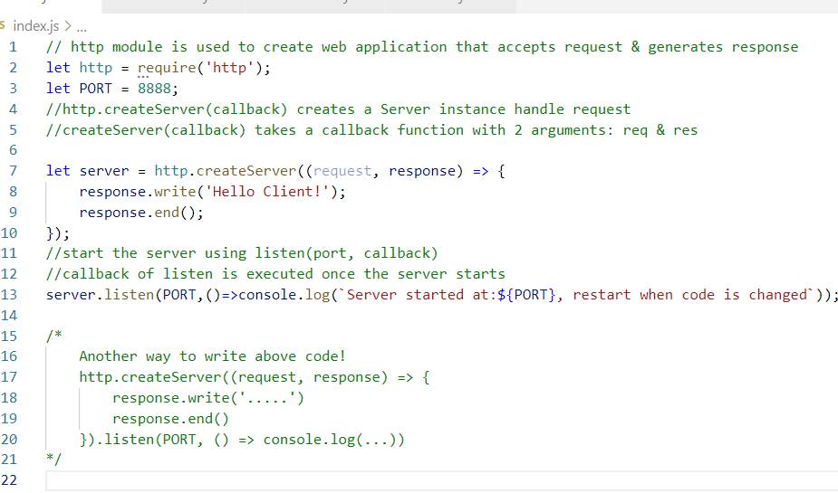

http module helps you to create web application, this provides createServer() to create a server instance on which you need to call listen() function to start, there are callbacks to execute when the server starts & when the request is sent.

You need to run this using node index.js and also you need to stop & re-run if in case you change your code.

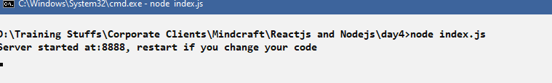

Output:

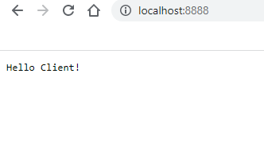

Note: We have entered <http://localhost:8888> to send request as server is running in port 8888

Writing HTML content

By Default response writes text content, hence you need to set the content type of the response to text/html so that it will be treated as HTML content by the browser

response.writeHead(statusCode, {‘content-type’:’text/html’});

writeHead() is used to provide properties to the response header about the content type and the response status code,

content-type: since by default content-type is plain/text we want that to be treated as HTML we can use text/html

statusCode: It is a standard number used by HTTP, this is response status like 200, 201, 202, 204, 401, 404, 405 and so on, these are some numbers if they are 2xx series it means it’s a successful response, if they are 4xx series then they are error responses.

200: OK

201: Created

204: No content

401: Unauthorized

404: Resource not found

index.js

Without content-type the content is treated as text

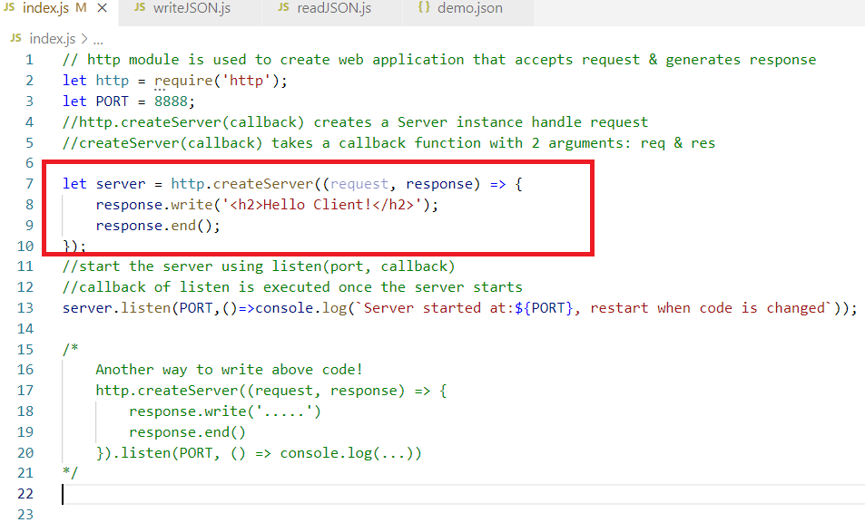

Output:

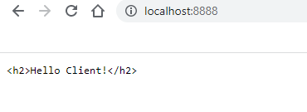

Since the response content is text it is not treating <h2> as HTML element, hence you must use response.writeHead(statusCode, {content-type:’text/html’})

index.js

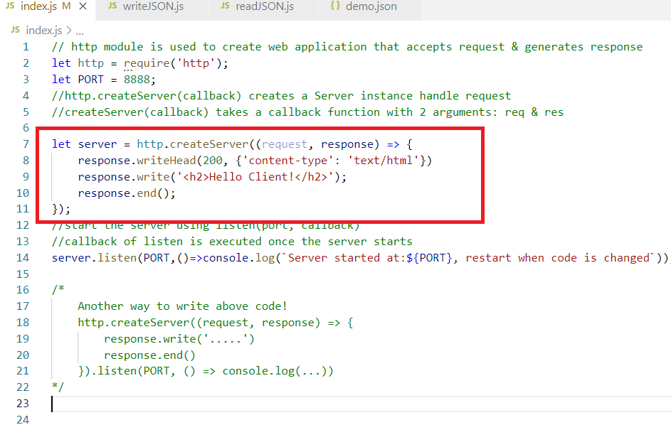  
Since the content-type is mentioned the browser would interpret the content as html

Output;

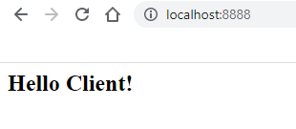

Webservices:

These are web applications that can take request from the applications instead of browser and they generate response in JSON format instead of HTML format

Webservices makes applications to exchange their data regardless of the language they use.

ex: Phone pe is an application (written in some language) sending data to All Banking application(each may be written in different languages), they can exchange the data without any problem because they use webservices

What webservice does

It accepts data in JSON and returns response data in JSON so that the end applications can convert the JSON to the types they understand.

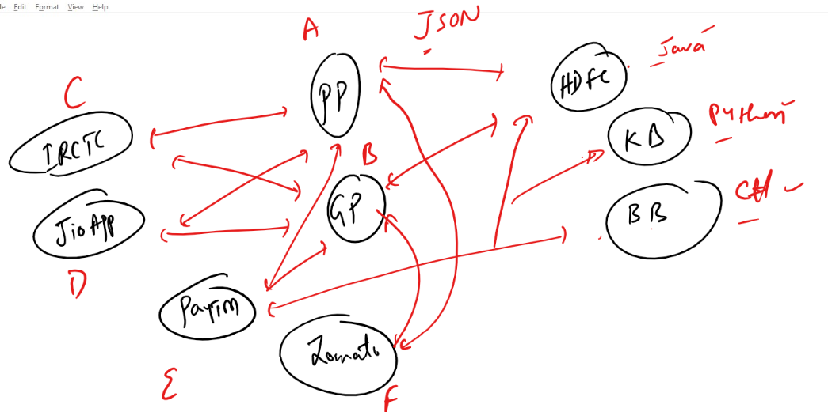

Note: We need to create webservices which can accept JSON and return JSON so that end applications can convert JSON to their target languages

We are going to create webservices in Javascript, but you can create webservices in other languages also like Java, C#, Python, C++ and so on

Since Backend webservices take request from many types of applications we have a Postman tool to test our webservices, the Postman tool can send request to webservice and get response from the webservice

Designing webservices

1. URL: Webservices must have an url which can be used by clients to access
2. HTTP methods: Webservices must use some HTTP methods to specify their operations, since all the operations are part of CRUD operations like Create, Retrieve, Update & Delete, in HTTP methods there are 4 methods to represent these operations
   1. POST: Create
   2. GET: Retrieve
   3. PUT: Update
   4. DELETE: Delete
3. Datastructure: The data must be in a common format which client (Consumer) & Server (Producer) can understand i.e., JSON most of the times 99.9%, but there are other formats which are not widely used but understood by consumer & producer they are: XML, TEXT, CSV

ReST Webservices:

ReST stands for Representational State Transfer, it is the name of the webservice which has some meaning,

Representational means data representation like JSON, XML, TEXT, CSV and so on.

State means data

Transfer means transfer/send

How to create ReST webservices in Node.js

We need to use a library called express.js library to implement webservices, to download express js you need to use npm command from node.js

i.e., npm install express

(or)

npm i express

When you install the express, it creates a node_modules folder that will have the express.js library which you can import in your code using require(“express”)

package.json: It is created automatically that shows all the libraries installed in your project when you download any node modules

Installing express.js in the project folder

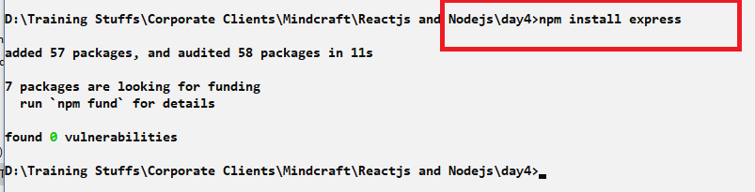

Note: The location where we installed express is day4 folder, in that location you must see node_modules & package.json both

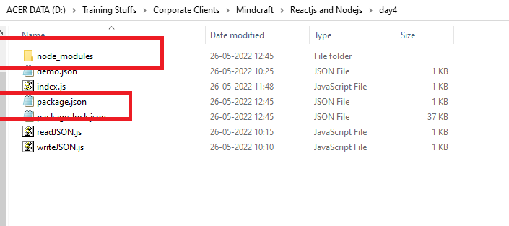

node_modules; Keeps all the javascript you download

package.json: it is a configuration file that keeps the libraries downloaded, so that anybody getting package.json can re-install these libraries using ‘npm install’

package.json should looks like this

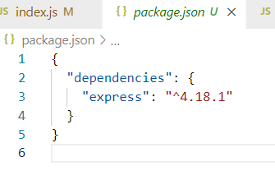

Now we can use this express library can create webservices

let express = require(“express”) // imports express

let app = express(); // references the top level object of express

The app is an object of express that provides methods like listen(), get(), post(), put(), delete()

listen: takes 2 arguments 1st is port, 2nd is callback executed when the server starts

get(): takes 2 arguments 1st is url, 2nd is callback executed when request is sent with HTTP GET & the URL

Similar to get() other methods like post(), put(), delete() take 2 arguments where 1st is url & 2nd is callback executed when request is sent with HTTP methods & the URL

app.listen(port, callback); //this starts the server

app.get(url, callback);

app.post(url, callback);

app.delete(url, callback)

app.put(url, callback)

index.js

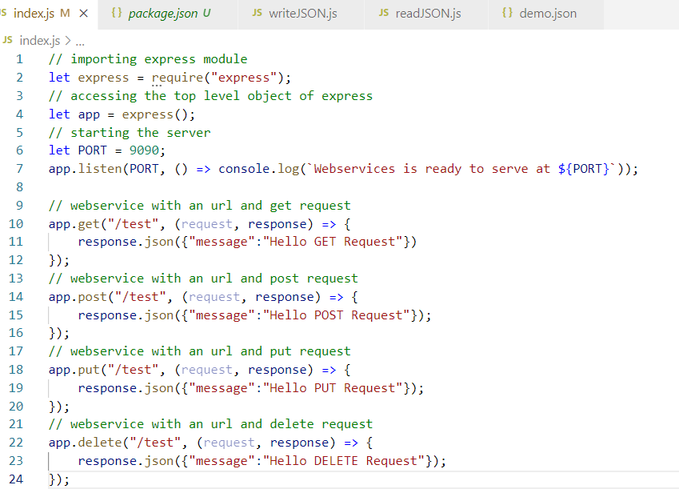

Run this program

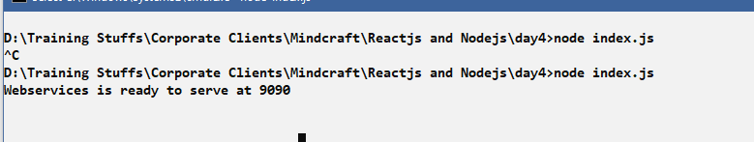

From Postman you need to send request, you have an option to choose different HTTP methods like get, post, put, delete and also to enter URL, you see response data in the postman as well

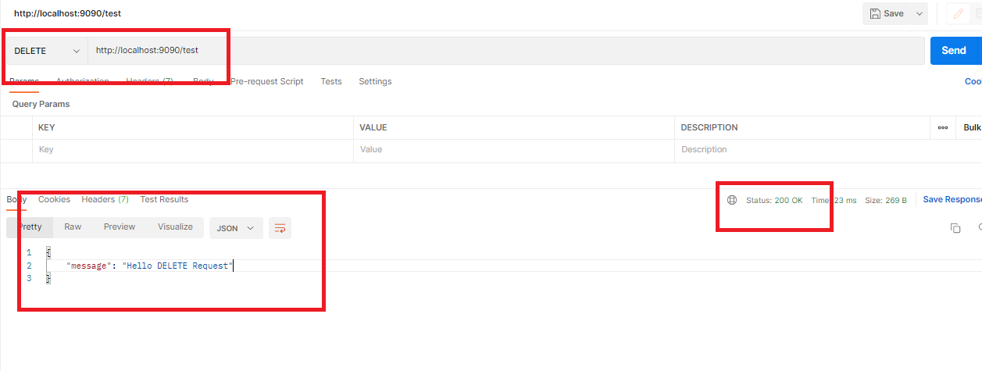

Sending JSON data to the webservice

From the client program you can send JSON to the webservice so that webservice can read that JSON data and convert to the type it understands, but here postman needs to send the JSON data to the webservice.

The client sends the data from the request body, except GET all other methods can send the data via request body.

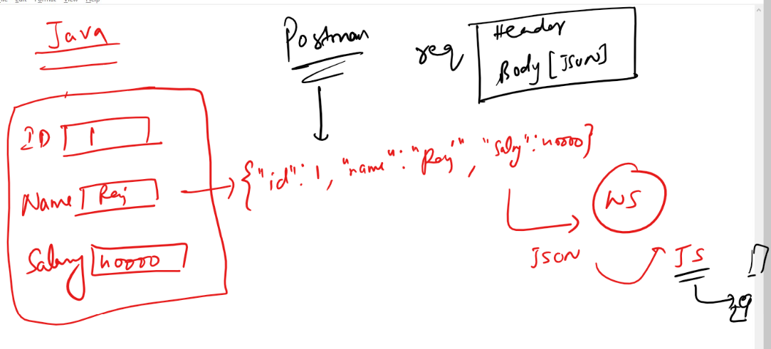

Since we don’t have client, we can use postman to send JSON data to the webservice, since our webservice is in Javascript we can use a property called request.body that extracts the data from the request body.

We need to parse the request body using a library called body-parser, that converts the JSON to Javascript

let bodyParser = require(“body-parser”);

let app = express();

app.use(bodyParser.json()) // this takes care of reading the json data form the request body

(request, response) => {  
 let data = request.body; // it extracts the data from the request body i.e., json data  
}

Note: When you use request.body, it automatically converts json to javascript

Installing body-parser

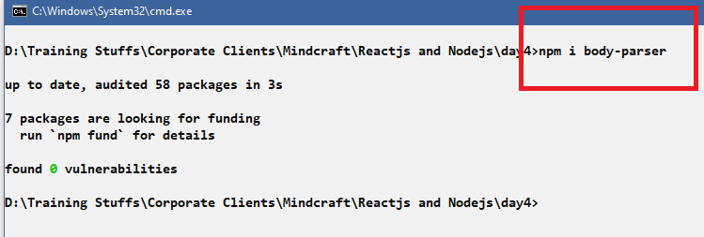

Verify the package.json has this body-parser entry also

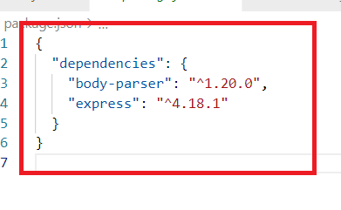

Why we need body-parser

This parses the request body so that when you use request.body it takes care of converting JSON to Javascript object

The express module gives a function called use() which takes an argument of what it has to parse, hence you need to write app.use(bodyParser.json())

index.js

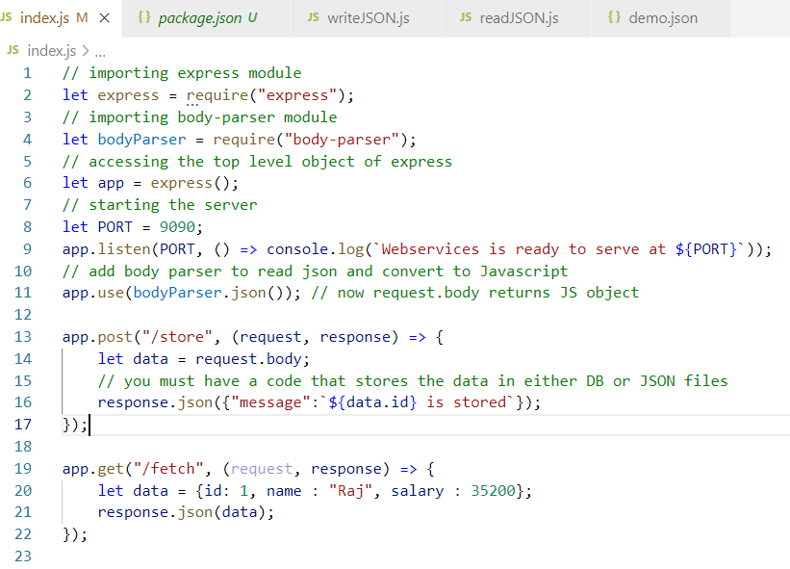

Here the postman sends a json data to the /store using POST, the app.post() reads the request.body and accesses id from the object and returns the message in json format.

The get(“/fetch”, (…) => {}) is to just understand that response.json() takes Javascript object and converts to JSON automatically

Output:

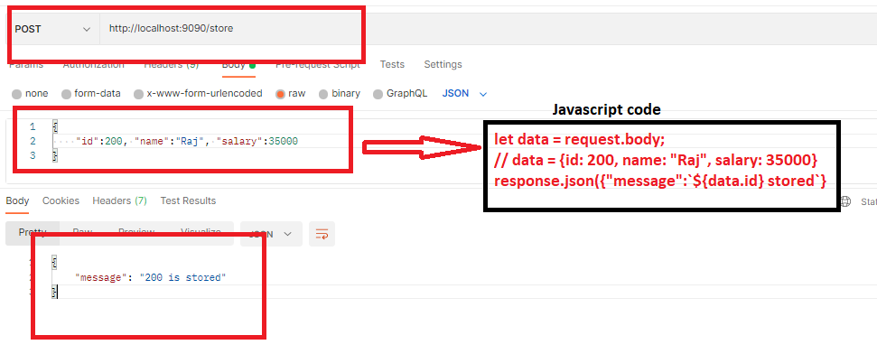

Passing parameters to the webservices

Like client can wrap the data in the request body, the client can also send the dynamic data in the path so that webservices can extract those paths.

client can use /fetch/1, /fetch/2, /fetch/3 and so on, where 1, 2, 3 are some dynamic values send via URL, however the webservices can be matches to above url’s with single end point url i.e., /fetch/:parameterName.

Here /fetch/:parameterName is a webservice URL that can match to /fetch/100, /fetch/200, /fetch/300 and so on, the ’:parameterName’ has a colon which means it can accept any value

app.post(“/store/:id”): Then you can access this using HTTP post and url could be /store/1, /store/2, /store/3 and so on

/store/:id matches to

/store/1: Here request.params.id returns 1

/store/2: Here request.params.id returns 2

/store/3: Here request.params.id returns 3

app.get(“/fetch/:id/:name”): Then you can access this using HTTP get & url could be /fetch/1/Raj, /fetch/2/Ram, /fetch/3/Vijay and so on.

/fetch/:id/:name matches to

/fetch/100/Raj: Here request.params.id returns 100 & request.params.name returns Raj

/fetch/200/Ramesh: Here request.params.id returns 200 & request.params.name returns Ramesh

app.put(“/update/:id/:salary”): then this can be matched to /update/1/25000, /update/2/30000 and so on

/update/:id/:salary matches to

/update/100/30000: Here request.params.id returns 100 & request.params.salary returns 30000

Note: The above path parameters helps to send a fewer data to the webservice while searching or updating or deleting any resources at the backend.

index.js

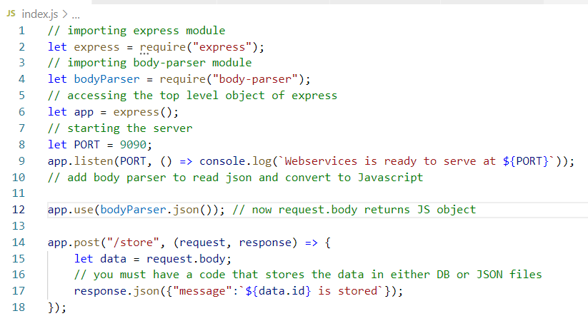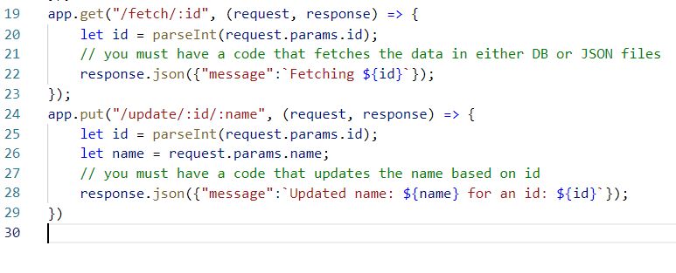

Here the request.params.parameterName will extract the path parameters like :id, :name hence you must use that as /:id & /:name, the client can send the data to this end point using the path

Output:

GET /fetch/100

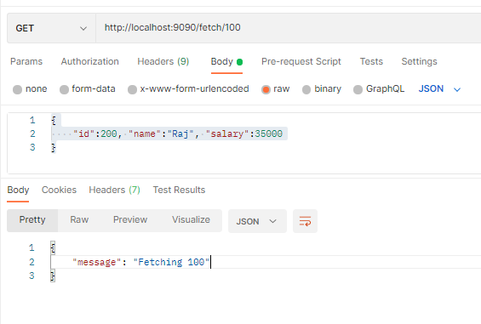

PUT update/100/Raj

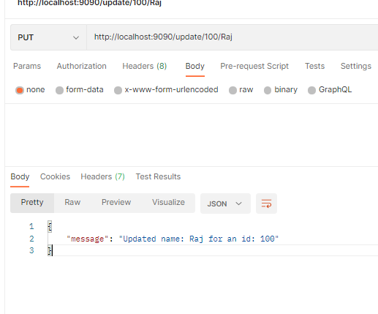

In Both the cases client sends some data through URL, but the webservices needs to use that data to perform some operations like using those parameters to access some information’s in the JSON file or Database.

Activity:

1. Try the above activity
2. Create Webservices that can accept the data from the POSTMAN and maintain those data in a JSON file, use a single JSON file to store & fetch
   1. Create a POST method that accepts the JSON data and stores that JSON data in a JSON file, ensure previous JSON data is not lost in the file and also keep all the JSON data in the form of array
   2. Create a GET method that reads the JSON file and returns all the JSON data in the response, you must see array of JSON in the POSTMAN
   3. Create a GET method that accepts a path parameter of id and use that id to search the user matching to the id in the JSON file if found then return the entire JSON data of that user in the response else return a message in JSON form, that user with an id not found.

Hint: /fetch/:id

Expected Output : Either the json data having the id or json data having a message that says the particular id not found